ContactManagement_Verify Contact notes _Instance44_12-Jul-2018_05-51-20_AM_SingleSignOn.png

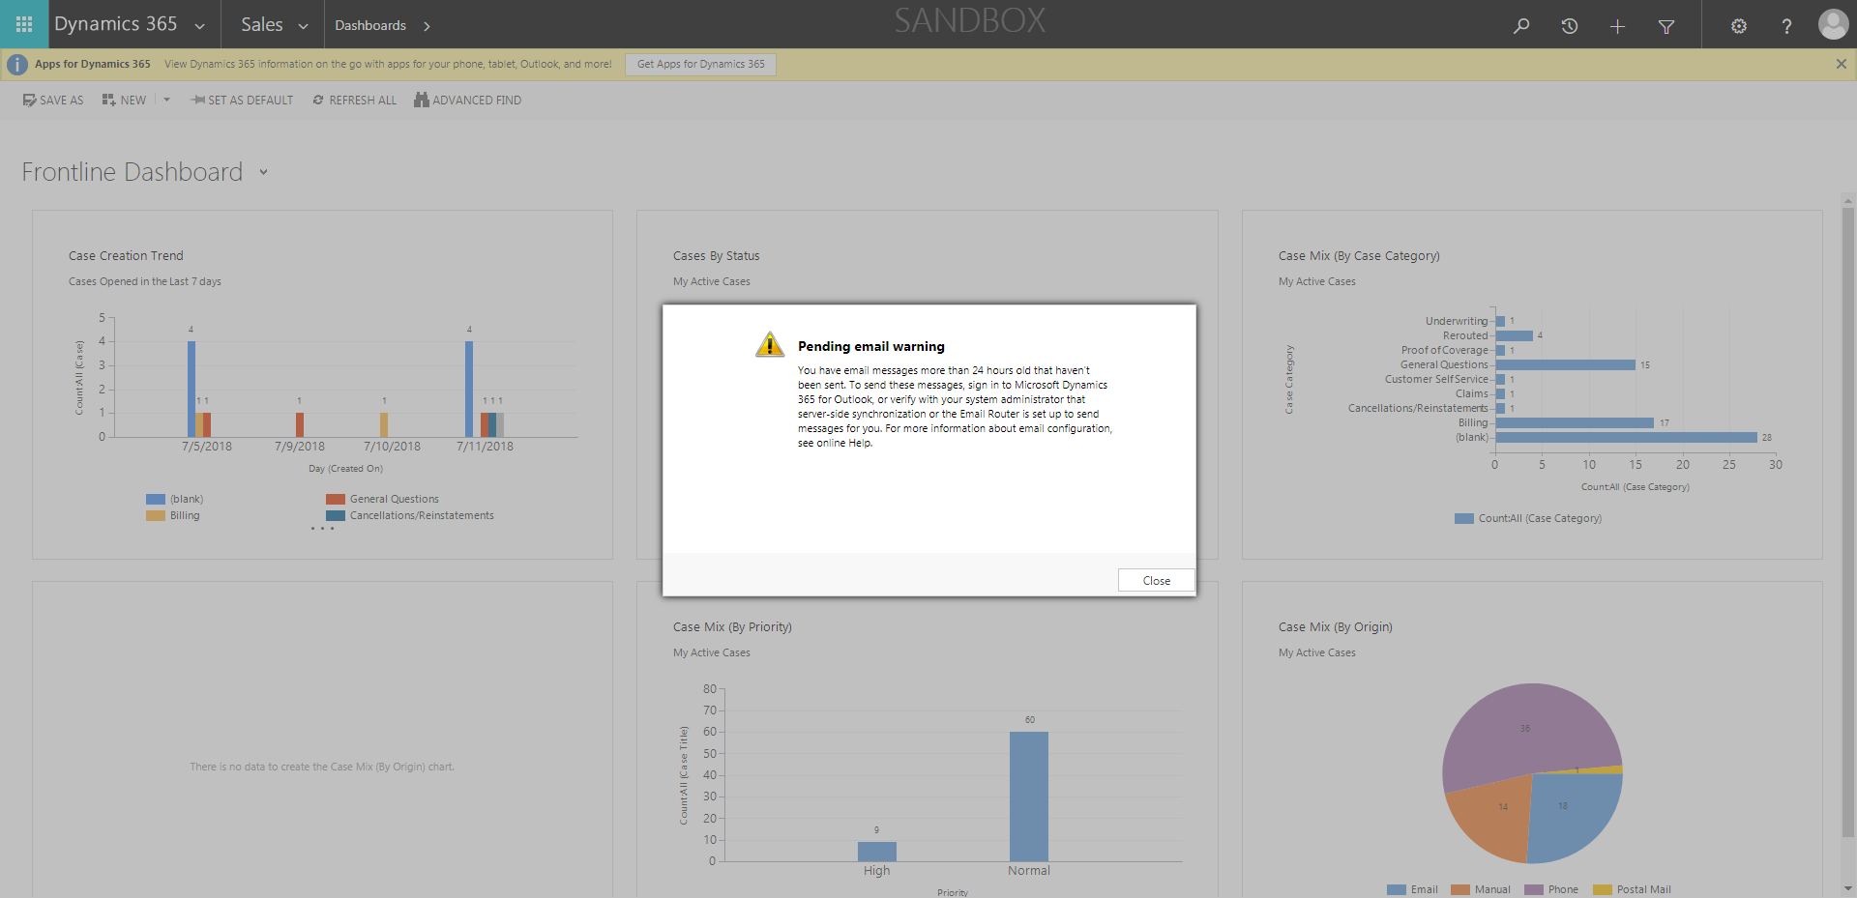

ContactManagement_Verify Contact notes _Instance44_12-Jul-2018_05-51-06_AM_MouseClickActiononStaleElement.png



ContactManagement_Verify Contact notes _Instance44_12-Jul-2018_05-52-36_AM_VerifyingAllNotesofanindividual.png

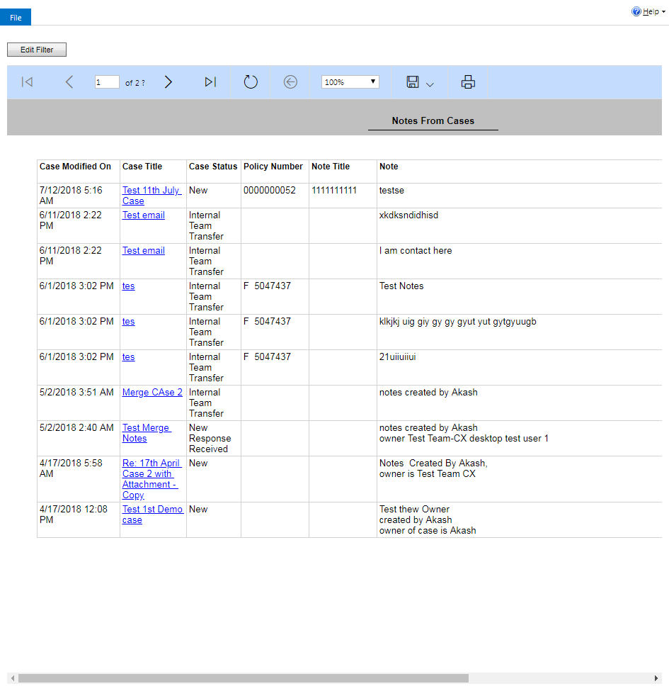

ContactManagement_Verify Contact notes _Instance44_12-Jul-2018_05-51-24_AM_SingleSignOn.png

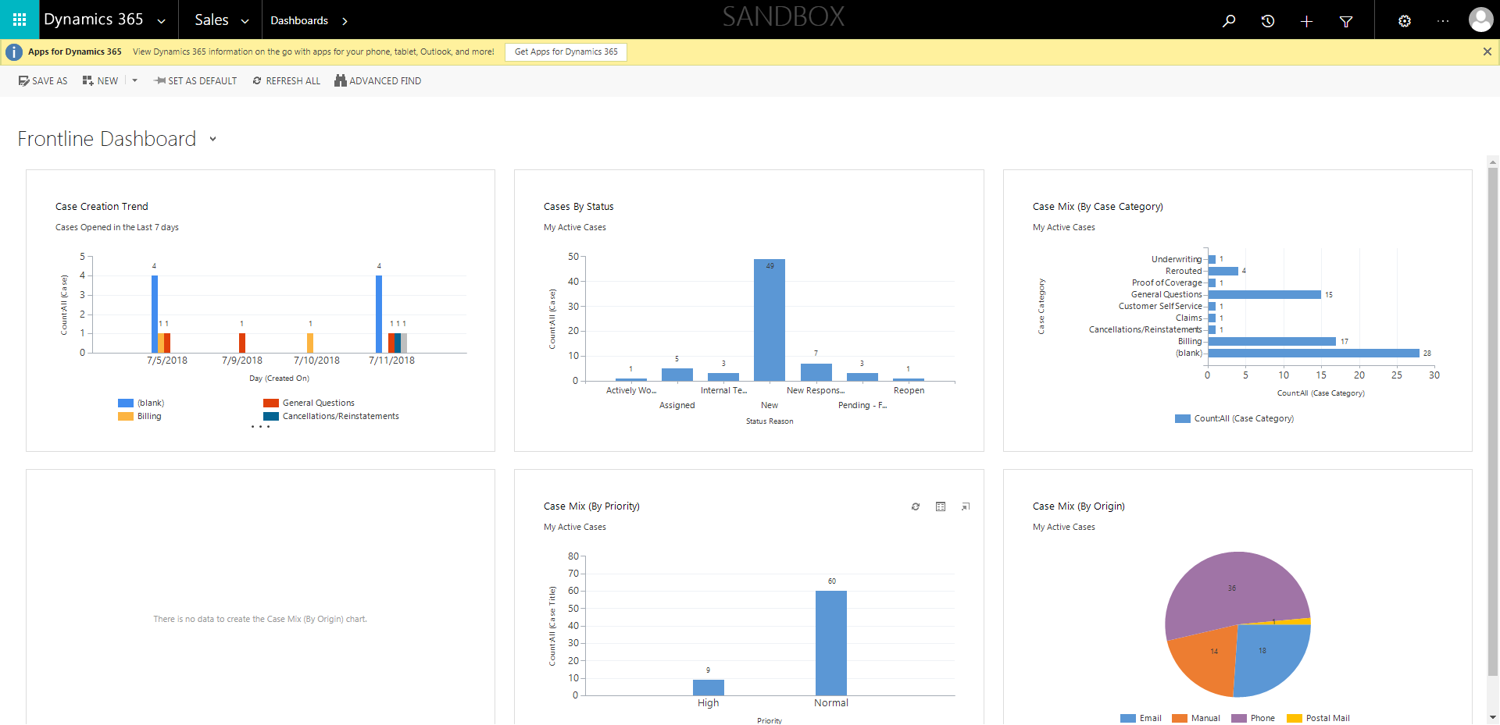

ContactManagement_Verify Contact notes _Instance44_12-Jul-2018_05-52-34_AM_VerifyingLatestNotesofanindividual.png



ContactManagement_Verify Contact notes _Instance44_12-Jul-2018_05-51-07_AM_EnterTextAction.png



ContactManagement_Verify Contact notes _Instance44_12-Jul-2018_05-51-08_AM_MouseClickActiononStaleElement.png

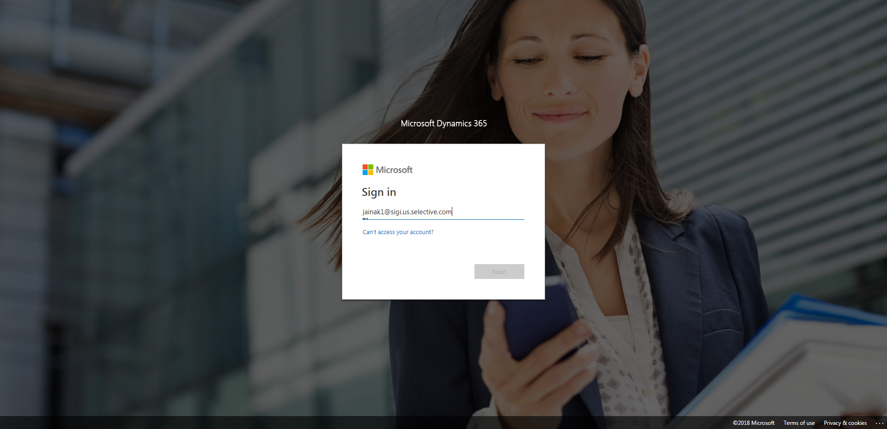

ContactManagement_Verify Contact notes _Instance44_12-Jul-2018_05-52-28_AM_Validatingcontactentitynavigation.png

